Chapter 6, Solution 53.

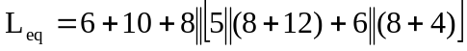

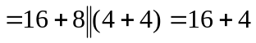

L_{eq} = 20 mH

